**The hard game**

Pc based consoles

This game is intended for everyone

This game is rated e for everyone

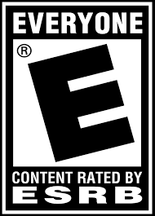

Sidescroller maze game

**Game story summary**

Your going through obstacles collecting anything that will allow you to proceed to the next level

You have to dodge the obstacles to proceed

**Unique selling points**

Enter a fun filled puzzle game that will push you to the limits on how to solve it and go to the next fun maze.

**Competitive products**

The worlds hardest game ever is similar it uses mazes obstacles and going to the next level.

Their both pc based console game played with a keyboard and a mouse.